FILE PERMISSIONS

Read Permission – 4
Write Permission – 2
Execute Permission – 1

Permission to users – owner, group and others

* Read permission allows only viewing directory contents.
* Write permission allows creating new files or deleting files.
* Execute permission allows changing into the directory only.

Default permissions : Create a folder and then check the permission.

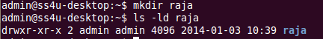

Create a file and check the permission.

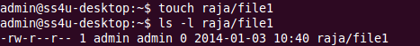

After change permissions : Give full permission to folder
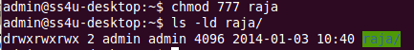

Give full permission to file

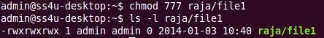

Default owner and group : Check the default owner and group of folder.

Check the default owner and group of file.

After change owner and group : In folder, change admin to root
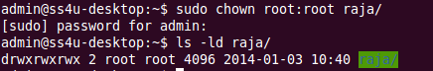

In file, change admin to root


